3-Climate

The purpose of CLIMATE is to estimate the effect of temperature, precipitation, radiation, and soil physical properties on the establishment of tree species, growth of plants, and decomposition of dead pools. The data used to drive these estimates are found in the ClimateZone.dvr, RadiationZone.dvr, SoilZone.drv, and TopographicZone.drv files. In terms of climate and radiation, it is possible to either use average monthly climate values or to have a long term record of monthly climate and radiation variables.

This module contains 15 functions. TempConvert, DegreeDays, the functions that estimate interception (CanInterception, LogIntercept, ForFloorInterception, and Total Interception), water stores (PET & Transpire, WaterStore, and WaterPot), the effects of climate on decomposition (MoistDecayIndex, TempDecayIndex, and AbioticDecayIndex) as well as growth (TempProdIndex, MoistProdIndex, and ProdIndex) are calculated each month on each stand grid cell. The variables are named using differing prefixes depending upon the time step used and whether they are annual averages or totals. Variables calculated on a monthly time step have the prefix Mon. Variables that are averaged over the year have the prefix Annual, and those that are yearly totals have the prefix TotalAnnual.

To speed processing, CLIMATE is solved for every combination of the climate, radiation, soil, and topographic zone. While there can be a significant number of combinations, there is still considerably less than if each stand grid cell is modeled separately. LANDCARB creates a number of extra stand grid cells, one to represent each zone combination. Because each stand grid cell in a the actual landscape can be in different stages of succession, the CLIMATE module assumes successional status of the extra stand grid cells representing the zone combinations. Given the lack of disturbance in these extra stand grid cells, for most of a simulation the forests in these are in the old-growth stage of succession. This is suitable to provide a general indication of climate effects, but will not represent losses via run-off or other processes sensitive to forest age.

The variables calculated in this module are used by the PLANT, GROWTH, asnd DECOMPOSE modules. To keep the time step the same as used in these modules the output information has been converted to annual means or sums depending on the variable.

TempConvert Function.

This function converts mean daily temperature based on a 24 hour period into the mean day time temperature required by the TempProdIndex function. Temperature is converted to the mean daytime temperature using the mean monthly 24 hour temperature (Temp24) and the mean maximum temperature (TempMax):

MonTempDay= 0.212* (MonTempMax-MonTemp24) +MonTemp24

where MonTempDay is the daytime temperature.

For the purposes of computing the respiration costs of living plant parts, the mean annual temperature (MeanAnnualTemp) is computed from the MonTemp24 values.

DegreeDays Function.

This function computes the degree days for the site. This is computed once per simulation run. The degree days (DDays) is the sum of all temperatures for all the days exceeding 5.56 C. To compute DDays we first compute the mean daily temperature from the mean monthly values stored in the ClimateZone.dvr file. This is done by linearly interpolating between the midpoint of each month. The daily change in temperature between each month is:

TempChangeMon1=Temp24Mon2-Temp24Mon1/JulianMon2-JulianMon1

where these are the daily temperatures (Temp24) for the respective months and the Julian day of the midpoint of months 1 and 2. Given the daily rate of change, the Julian day, and the mean monthly temperature the daily temperature (TempDaily) is computed:

TempDaily=TempMon1+TempChangeMon1*(Julian-JulianMon1)

where Julian is the Julian day, and the other variables are as defined above. The total degree days is then computed by adding all the temperatures of the days exceeding 5.56 C.

CanInterception Function.

This function calculates the amount of canopy interception based upon the plant life-form, mean monthly precipitation, and the mass of foliage as calculated in the GROWTH module. Each layer occupying a stand grid cell is capable of intercepting precipitation.

The interception rate generally decreases with increasing precipitation (Rothacher 1963, Lee 1980, Ward and Robinson 1990, Figure 3-1). This relationship is simulated by:

MonLayerCanIntRate= LayerCanopyInterMin
+(1- LayerCanopyInterMin)*Exp(-0.75*MonLayerPrecip)

where LayerCanopyInterMin is the minimum interception per Mg of foliage as set by the user in the GrowLayer.prm file and MonLayerPrecip is the amount of precipitation falling through a layer.

The interception by each layer also increases linearly with increasing foliage mass (Figure 3-2). This simulates the increase in interception observed with stand age and density (Ward and Robinson 1990). As leaf mass varies seasonally for some species, canopy interception also varies monthly depending on the life-form. Deciduous trees (i.e., those trees with a foliage turnover rate of 1.0 in the Mort.prm file), herbs, and shrubs have minimal interception (5%)

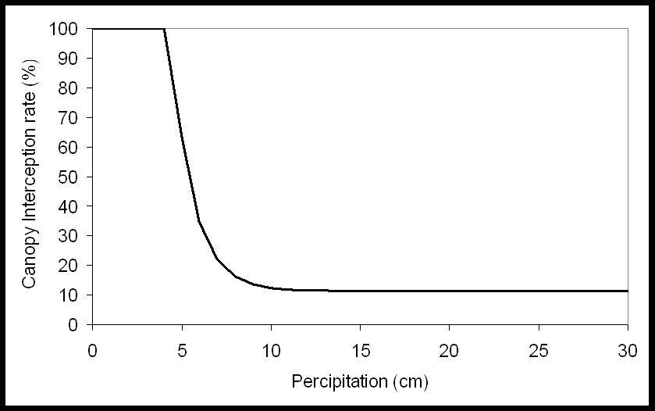
Figure 3-1. Relationship between the monthly precipitation rate and canopy interception used in the LANDCARB model.

during the non-growing season (i.e., the months of November through April). In contrast, evergreen trees have the potential for high interception year round. The proportion of precipitation intercepted by foliage of all the layers in a given month and stand grid cell is:

MonCanInterception=MonPrecip* Σ (MonLayerCanIntRate*LayerFoliage)

where LayerFoliage is the mass of foliage for a particular layer in a stand grid cell. Canopy throughfall is the fraction of the precipitation that is not intercepted by the canopy:

MonCanThroFall=MonPrecip-MonCanInterception

where MonCanThroFall is the amount of precipitation allowed to pass through the canopy each month and MonPrecip is the mean monthly precipitation as defined by the Climate.dvr file.

LogIntercept Function.

This function estimates the amount of interception from the deadwood pools including those associated with snags, logs, and stable wood from their mass as calculated in the Decompose module. It also adjusts the interception as a function of the maximum moisture content of the woody material.
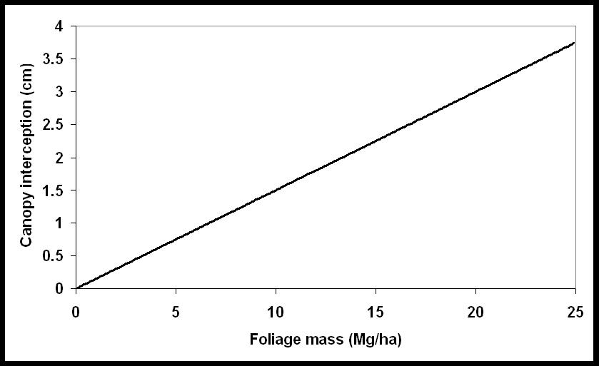

Figure 3-2. Amount of canopy interception as a function of foliage mass in the LANDCARB model.

The first step is to calculate the projected area of each dead wood pool from its mass:

PoolProArea=PoolAreaMassRatio*Pool/100

where PoolProArea is the projected area in percent of the stand grid cell surface area, and PoolAreaMassRatio is the ratio of projected area to mass of the dead wood pools. The latter parameters are found in the DecayPool.prm file. Pool can be either SnagSapwood, SnagHeartwood, LogSapwood, LogHeartwood, DeadBranches, or StableWood.

The next step is to calculate the amount of MonCanThroFall intercepted by the woody detrital pools. The amount intercepted is a function of the maximum potential interception based on area (MaxPotInterceptionArea) and the maximum potential based on the storage capacity (MaxPotInterceptionCap). The maximum potential interception based on area is:

MaxPotInterceptionArea=PoolProArea*MonCanThroFall

where PoolProArea is the projected area of a pool and MonCanThroFall is the monthly canopy throughfall as calculated above. The maximum potential based on the storage capacity (MaxPotInterceptionCap) is calculated first by calculating the maximum storage capacity of the dead wood pool:

MaxStoresCap= StoresMax- StoresAct

where the maximum possible water store is:

StoresMax=Pool*PoolMoistStoreMax/100

where PoolMoistStoreMax is set in the DecayParm.prm file. The actual current water stores is:

StoresAct=Pool*MonPoolMoist/100

where MonPoolMoist is calculated by the CLIMATE WaterStore function. The maximum potential interception based on storage capacity is:

MaxPotInterceptionCap=MaxStoresCap/100

assuming there are 100 Mg/ha of water in 1 cm of precipitation.

The amount of canopy throughfall (MonCanThroFall) intercepted by the dead wood pools depends on the relationship of the maximum potentials based on area and storage capacity. If MaxPotInterceptionArea is less than or equal to MaxPotInteceptionCap then:

MonPoolInter=MaxPotInterceptionArea

If, on the other hand, MaxPotInterceptionArea is greater than MaxPotInterceptionCap, then:

MonPoolInter=MaxPotInterceptionCap

This relationship assures that the dead pool can not absorb more water than the dead pool can store. The last step is to calculate the amount of canopy throughfall that is passed on to the forest floor. The amount added to the forest floor each month as log throughfall is:

MonLogThroFall= MonCanThroFall- Σ MonPoolInter

The total interception by the dead woody pools is:

MonLogInteception = Σ MonPoolInter

ForFloorInterception Function.

This function estimates the amount of interception by the dead foliage pool (DeadFoliage) as well as a stable carbon pool ( StableFoliage) derived from dead foliage. Water is first removed by the DeadFoliage pool; whatever is passed through this layer is partially removed by the StableFoliage pool. The amount intercepted by each pool is a function of the mass as calculated in the DECOMPOSE module and the maximum moisture content of the detrital pool.

We assume that until a certain mass, these pools do not cover the stand grid cell surface completely. If these pools are less than or equal to 3 Mg/ha, the projected area is calculated as:

PoolProArea=PoolAreaMassRatio*Pool/100

where PoolProArea is the projected area of either the dead foliage or stable pool and PoolAreaMassRatio defines the relationship between mass and projected area as defined in the DecayPool.prm file. If on the other hand the mass exceeds 3 Mg/ha then

PoolProArea=1.0

The amount intercepted by the dead foliage and stable foliage pool each month is a function of the maximum potential interception based on area (MaxPotInterceptionArea) and the maximum potential based on the storage capacity (MaxPotInterceptionCap). The maximum potential interception based on area is:

MaxPotInterceptionArea=PoolProArea*MonLogThroFall

where PoolProArea is the projected area of a pool and MonLogThroFall is the monthly log throughfall as calculated above. The maximum potential based on the storage capacity (MaxPotInterceptionCap) is calculated first by calculating the maximum storage capacity of the dead wood pool:

MaxStoresCap= StoresMax- StoresAct

where the maximum possible water store is:

StoresMax=Pool*PoolMoistStoreMax/100

where PoolMoistStoreMax is set in the DecayPool.prm file. The actual current water stores is:

StoresAct=Pool*MonPoolMoist/100

where MonPoolMoist is calculated by the CLIMATE WaterStore function. The maximum potential interception based on storage capacity is:

MaxPotInterceptionCap=MaxStoresCap/100

assuming there are 100 Mg/ha of water in 1 cm of precipitation.

The amount of log throughfall (MonLogThroFall) intercepted by these dead foliage related pools depends on the relationship of the maximum potentials based on area and storage capacity. If MaxPotInterceptionArea is less than or equal to MaxPotInteceptionCap then:

MonPoolInterception=MaxPotInterceptionArea

If, on the other hand, MaxPotInterceptionArea is greater than MaxPotInterceptionCap, then:

MonPoolInterception=MaxPotInterceptionCap

This relationship assures that these dead foliage related pools can not absorb more water than it can store. The amount added to the soil as throughfall from the dead foliage pool each month is:

MonForestFloorThroFall=MonLogThroFall-MonDeadFoliageInterception
-MonStableFoliageInterception

Total Interception Function.

This function calculates the total amount of precipitation intercepted by the canopy, above-ground dead wood pools, and the dead foliage pool (Figure 3-3, 3-4). The monthly total interception is:

MonTotalInterception=MonStableFoliageInterception +
MonDeadFoliageInterception+MonLogInteception+MonCanopyInterception

TotalAnnualInterception is the sum of all the monthly interception values.

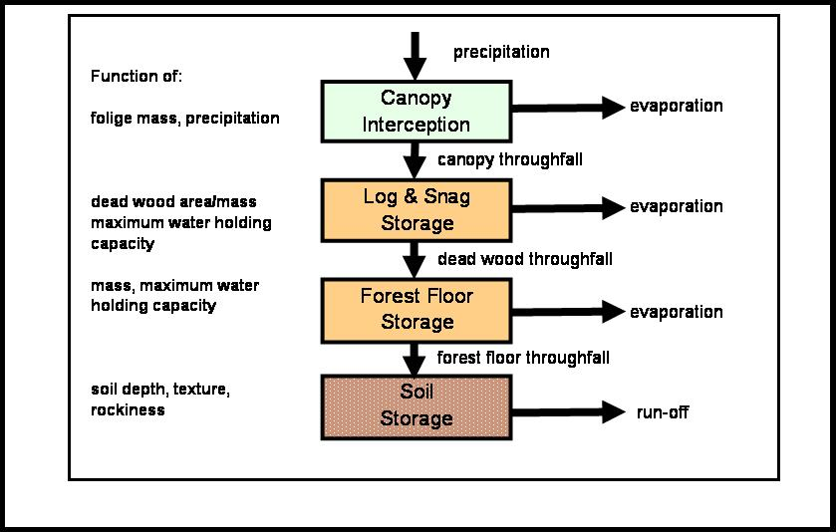

Figure 3-3. Pools and processes leading to interception in the LANDCARB model.
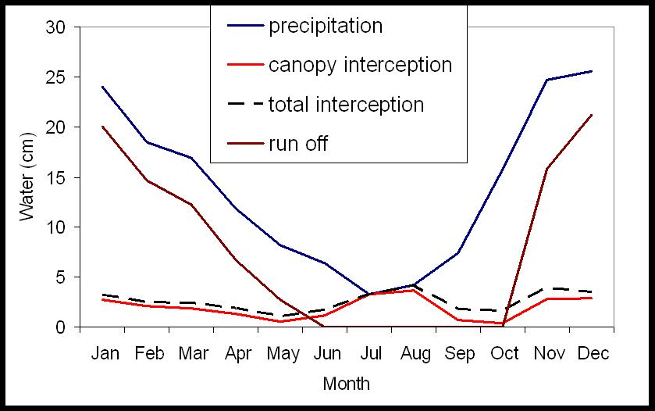

Figure 3-4. Examples of seasonal trends in water flow predicted by the LANDCARB model.

PET & Transpire Function.

This function calculates the monthly total potential evapotranspiration (in cm) of the site using a modification of the Priestly-Taylor method (Bonan 1989, Jensen 1973, Campbell 1977). Total potential evapotranspiration for a month (MonPETTotal) is assumed to be proportional to the estimated solar radiation (MonSolRad), the monthly mean air temperature (MonTemp24 in C), and number of days in a month (MonthDay).

MonPETTotal=CT*(MonTemp24+TX)*MonSolRad*MonthDay/MonLatHeatVapor

The constants CT and TX are empirically derived and calculated after Jensen and Haise (1963) and Jensen (1973):

CT = 1/[38-(2*Elev/305) + 380/SatVapPresMax-SatVapPresMin)]

TX = 2.5+(0.14*(SatVapPresMax-SatVapPresMin))+Elev/550

where Elev is the elevation in meters, SatVapPresMin and SapVapPresMax are the saturation vapor pressures in mbars for the mean minimum (TempMeanMin) and mean maximum (TempMeanMax) daily temperatures for the warmest month of the year. The vapor saturation pressures are calculated from the appropriate air temperatures using Bosen's (1960) approximation. For example for the SatVapPresMin:

SatVapPresMin=33.8639*[((0.00738*TempMeanMin+0.8072)8
- 0.000019*(1.8*TempMeanMin + 48) +0.001316)]

MonLatHeatVapor is the latent heat of vaporization (cal) for each month and is calculated as follows:

MonLatHeatVapor= 597.-0.568*MonTemp24

This means that each month can have its own value of latent heat of vaporization.

To estimate the potential amount of transpiration by plants (MonPotenTrans), the total potential evapotranspiration (MonPETTotal) is reduced by the amount of evaporation from canopy interception and dead pools:

MonPotenTrans=MonPETTotal-MonCanInterception-MonDeadEvaporation

MonPotenTrans is set so it can not go below zero. If the interception and evaporation terms are larger than PET total then set PotenTrans to zero. This yields a monthly potential transpiration loss, assuming that leaf mass and soil water stores are at a maximum (Figure 3-5). The actual transpiration losses each month (MonTranspiration) are controlled by the soil water stores and the foliage mass:

MonTranspiration=MonPotenTrans*(Mon-1)MoistProdIndex*(Foliage/FoliageMax)

where (Mon-1)MoistProdIndex is calculated in the MoistProdIndex function and is the value of the previous month, and Foliage is the total foliage mass for all layers and FoliageMax is the maximum total foliage mass possible in a stand grid cell. This is calculated for each layer from the light compensation point (LayerLightCompPoint) and the light extinction coefficient (LayerLightExtCoeff) for each layer in a stand grid cell. The first step is to calculate the maximum light a layer (LayerMaxLightAbsorb) can absorb assuming that the overlying layers are also at their maximum:

LayerMaxLightAbsorb=LayerLightIn-(LayerLightCompPoint/100)

where LayerLightIn is the light not absorbed by the overlying layers and LayerLightCompPoint is the light compensation point of the layer as defined in the Growth.prm file. In cases where the LayerLightIn is less than LayerLightCompPoint (when the overlying layers reduce light below the light compensation point of the layer in question), LayerMaxLightAbsorb is set equal to zero.

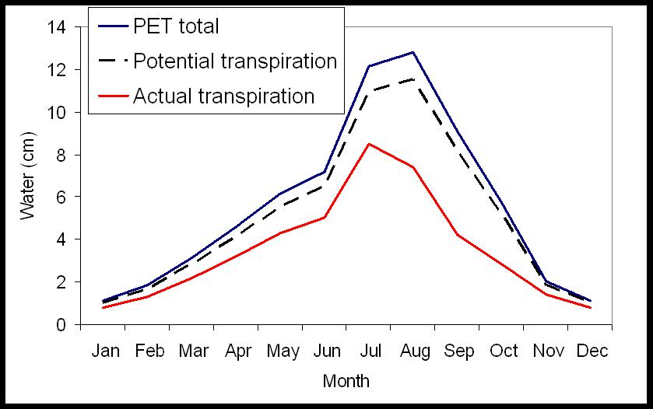

Figure 3-5. Examples of seasonal changes in transpiration predicted by LANDCARB model.

The maximum mass of foliage a layer can have, adjusted for the amount of light it can absorb is:

LayerFoliageMax= -Ln [LayerLightRemoved/LayerLightExtCoeff]

where LayerLightExtCoeff is the light extinction coefficient (defined in Growth.prm) and LayerLightRemoved is the amount of light removed by a layer:

LayerLightRemoved= (LayerLightIn-MaxLightAbsorbed)/LayerLightIn

The maximum foliage mass of all the plant layers is calculated as the sum of maximum foliage mass for all four layers in a stand grid cell:

FoliageMax=Σ(LayerFoliageMax).

WaterStore Function.

This set of functions determines the monthly moisture content of eight dead pools, two surface stable pools (i.e., StableFoliage and StableWood) and the mineral soil. For all pools, the moisture content is computed monthly and represents the balance of inputs through precipitation and outputs via evaporation and/or transpiration (Figure 3-6).
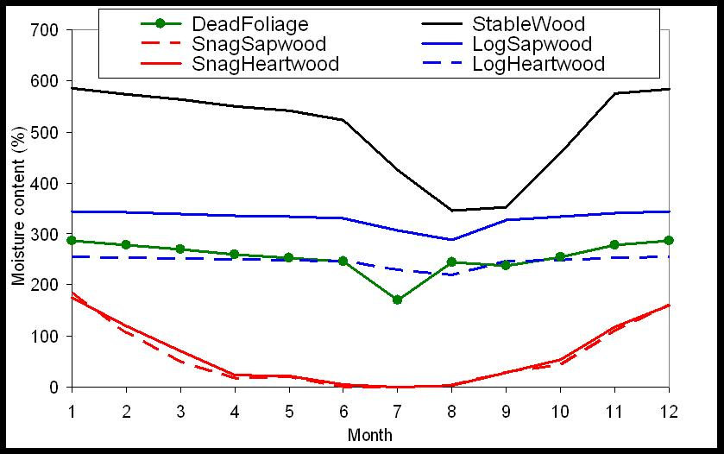

Figure 3-6. Example predictions of seasonal changes in moisture content (mass based) of selected dead carbon pools in the LANDCARB model.

Mineral Soil Subfunction.

This function computes the water stores in the mineral soil. Input to the mineral soil is whatever water has not been intercepted by the canopy, dead wood, surface stable pools, and the dead foliage pools.

MonSoilWaterIn=MonForestFloorThroFall

where MonSoilWaterIn is the amount of water added to the mineral soil layer in cm. The loss of water from the mineral soil will be controlled solely by the transpiration from plants, this assumes that there is always plant cover or forest floor cover. The overall balance of mineral soil water stores is therefore:

MonDeltaSoilWat=MonSoilWaterIn-MonTranspiration

The water stored in mineral soil for each month would be:

MonSoilWat= MonSoilWatOld +MonDeltaSoilWat.

where MonSoilWatOld is the water store in the soil the previous month. To keep the water potential and other indices from becoming undefined, the minimum value that MonSoilWat is allowed to have is 0.01.

To compute an overall water balance, runoff occurs when MonSoilWat exceeds the SoilWaterMax (the maximum storage capacity of the soil based on its texture, rockiness, and depth as calculated by the SoilTexture module). The monthly runoff is therefore:

MonRunoff=MonSoilWat-SoilWaterMax

When runoff occurs the MonSoilWat is set to equal SoilWaterMax. If the monthly water store is less than or equal to the maximum then MonRunoff is set to zero.

The annual Runoff is the sum of all the monthly values (TotalAnnualRunoff). While this variable is not directly used in carbon budgets, it is a useful variable for model calibration.

The moisture content of the soil is calculated on a volumetric basis relative to the maximum water storage of the particular site being examined:

MonSoilMoist= 100*MonSoilWat/SoilWaterMax

where SoilWaterMax is the maximum amount of water (cm) a soil can hold as calculated in SOILTEXTURE.

Dead Pool Water Stores Subfunction.

This function calculates the balance of water stores for four dead pools and two stable pools. The input of water into the DeadFoliage, DeadSapwood, DeadHeartwood, DeadBranch, StableFoliage and StableWood pools is equal to the amount intercepted:

MonPoolWaterIn=MonPoolInterception

DeadSapwood and Dead Heartwood are subdivided into snags and logs for water balance purposes. The loss of water each month from these pools is dependent upon the temperature and the amount of solar radiation received. The amount of solar radiation recieved each month is a function of the amount of light that passes through the foliage layer just above the dead pool. Therefore for Deadfoliage, DeadBranch, StableFoliage, StableWood, and DeadSapwood and DeadHeartwood in logs the amount of radiation recieved is:

MonPoolRadiationInput=MonSolRad*HerbLightOut

where MonPoolRadiationInput is the amount of radiation recieved by a detrital pool each month, MonSolRad is the total amount of solar radiation recieved by a site each month (see Radiate.dvr file) and HerbLight is the fraction of light passing through the foliage of all plant layers each month. In the case of DeadSapwood and DeadHeartwood in snags the amount of light recieved is higher given the greater height distribution of this material. Therefore:

MonSnagPoolRadiationInput=MonSolRad*UpperTreeLightOut

where MonSnagPoolRadiationInput is the amount of radiation recieved by DeadSapwood and DeadHeartwood in snags each month and UpperTreeLightOut is the amount of radiation passing through the upper tree layer. The rate of drying is dependent on the evaporative demand for each dead pool:

MonPoolEvapDemand=MonTemp24*MonPoolRadiationInput.

When MonTemp24 is negative, MonPoolEvapDemand is set to 0 so that dead pools do not directly gain water from the atmosphere. The rate that water is lost from each detrital pool is:

MonPoolRateWaterLoss=MonPoolEvapDemand*PoolDryingConstant

where PoolDryingConstant is found in the DecayPool.prm file. This parameter represents the rate of drying in a month when the temperature is 1C and the radiation input is
1 cal m-2 day-1.

The overall rate of change for each of the detrital layers and surface stable pools is a function of the inputs versus loss through evaporation:

MonDeltaPoolWater=MonPoolWaterIn-MonPoolRateWaterLoss

The store of water in a pool for a given month is:

MonPoolWater=MonPoolWaterOld+MonDeltaPoolWater

with the restriction that MonPoolWater can not be less than 0.

To calculate the effect of water stores in these detrital layers on the Moisture Decay Index functions, the values of water depth have to be converted to moisture content based on mass. The mass of water per hectare in 1 cm of depth is 100 Mg. Therefore each 1 cm of water stored in a detrital layer is:

MonPoolWaterMass=MonPoolWater*100

where Pool is any of the four detrital layers we are considering (DeadSapwood, DeadHeartwood, DeadBranches, and DeadFoliage). The moisture content for these pools would therefore be:

MonPoolMoist=100*MonPoolWaterMass/Pool.

where Pool is the mass of each dead pool during the year being considered.

In this version of the model there are two layers in which the moisture content is not modeled using inputs and outputs. For the dead fine root pool (DeadFineRoot), the moisture content changes rapidly with the surrounding soil and humus. It is therefore assumed to be the same as for the StableFoliage pool. In the case of dead coarse roots (DeadCoarseRoot) the water balance is controlled by the moisture of the surrounding mineral soil (Chen 1999). We assume that the response-lag over a monthly time step is minimal. When the soil is saturated we assume that the dead coarse roots reach their maximum moisture content. Therefore:

If MonSoilMoist = 100 then

MonDeadCRootMoist=DeadCRootMoistStoreMax

as defined in the DecayPool.prm file. When the moisture content of the mineral soil is less than saturated we assume the dead coarse roots and mineral soil are in equilibrium. However, since mineral soil moisture is expressed in volumetric terms and dead coarse roots in mass terms we must convert units:

If MonSoilMoist<100 then

MonDeadCRootMoist=2*MonSoilMoist

Finally, to calculate the potential transpiration losses from the mineral soil it is necessary to calculate the amount of water lost via evaporation from dead and the surface stable pools (MonDeadEvaporation):

MonDeadEvaporation= Σ MonPoolRateWaterLoss.

WaterPot Function.

This function converts the volumetric moisture content of soils to a xylem water potential (Figure 3-7). This relationship is represented by a reciprocal function modified by an asymptote:

MonWaterPot=CorrTerm*WaterPotAsym + (WaterPot1*(SoilWaterMax/MonSoilWat))

where MonWaterPot is the predawn xylem water potential in MPa for a given month, MonSoilWat is the monthly water store in soil, and SoilWaterMax is the maximum water stores in cm. The later variable is dependent upon the soil depth, rockiness, and texture and is calculated by SoilTexture. The parameter WaterPotAsym simulates the behavior of coarse textured soils that can yield considerable water without changing their water potential. WaterPot1 is the fraction of the water stores when WaterPot is equal to 1 MPa. When this water potential is reached moisture becomes limiting to transpiration and production. The values of WaterPotAsym and WaterPot1 are defined in the Soil.prm file. Finally, the term,
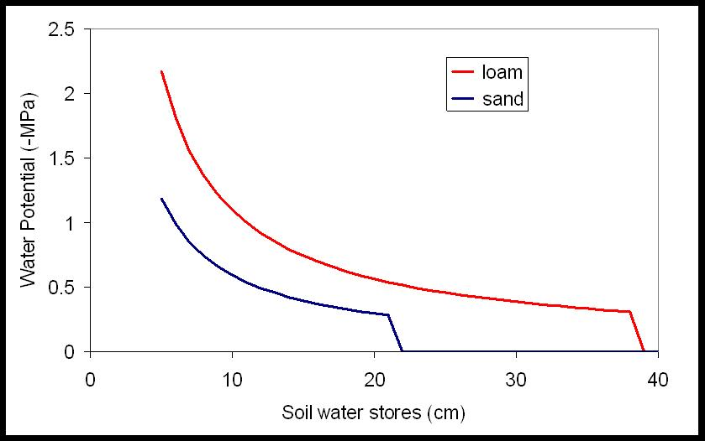

Figure 3-7. relationship between soil water stores and soil water potential used by the LANDCARB model.

CorrTerm, is used to correct for the fact that water potential does not increase appreciably from 0 when the soil is near saturation. CorrTerm is set equal to 0 if the ratio of MonSoilWat/SoilWaterMax is greater to or equal to 0.9. Otherwise CorrTerm is set to 1.

MoistDecayIndex Function.

This function determines the way the moisture content (MonPoolMoist) of each pool influences the decomposition rate of the detrital layers for each month (Figure 3-8). For all layers we assume that moisture controls decomposition in two ways. The first is through matric potential which makes water unavailable for decomposers. For most detrital forms, decomposition ceases when moisture content reaches the fiber saturation point. The second effect is caused by poor oxygen diffusion when the moisture content is too high. For most detrital layers this is not a problem, however, coarse wood respiration is often limited by this factor. We model the matric potential and diffusion limitation portions separately. For all dead pools except the stable soil pool, the percent moisture content used is based on mass of water divided by dry mass of the substrate. For the stable soil pool, the percent moisture content is based on volume of water divided by volume of soil.

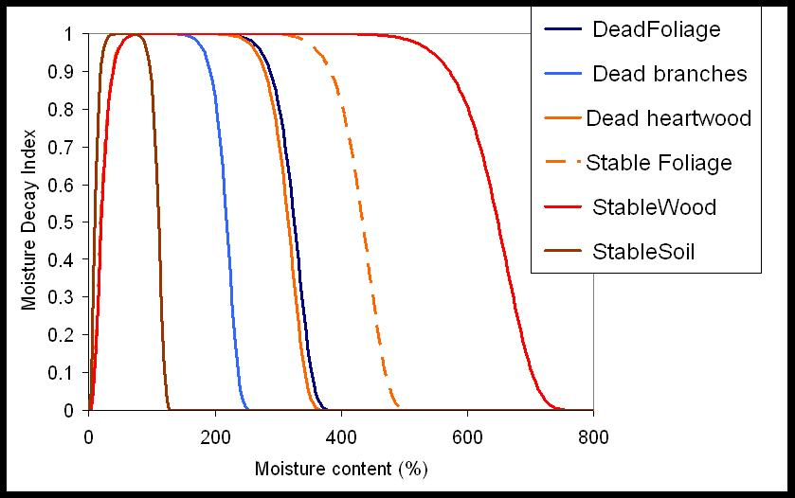

Figure 3-8. Relationship between moisture content and relative effect on decomposition rates of selected pools in the LANDCARB model.

The equation for the matric potential limitation (MonMatricLimit) of each detrital pool or the stable soil pool for each month is:

MonPoolMatricLimit=(1-exp[-IncreaseRate*(MonPoolMoist+MatricLag)])MatricShape

where MatricShape is a dimensionless number that determines when the Matric limit is reduced to the point that decay can begin to occur. The MatricLag parameter is used to offset the curve to the left or right. The IncreaseRate is the parameter determining the point at which the matric limitation ends. This parameter is determined from the minimum moisture content at which decay can occur:

IncreaseRate=3/MoistMin

The diffusion limitation (MonDiffuseLimit) is designed to mimic the reduction in decomposition caused when the substrate becomes water saturated. Water saturation causes a reduction in oxygen diffusion reducing decomposition. This function remains at 1 until the maximum moisture content without diffusion limitations is reached. The function decreases to 0 when moisture content exceeds the maximum for decomposition to occur. This function is calculated for each detrital pool for each month:

MonPoolDiffuseLimit=exp[-(MonPoolMoist/(MoistMax+DiffuseLag))DiffuseShape]

where MoistMax is the maximum moisture content without diffusion limitations, DiffuseShape is a dimensionless number that determines the range of moisture contents where diffusion is not limiting, and DiffuseLag is a parameter used to shift the point when moisture begins to limit diffusion. These parameters are stored in the DcayParm.prm file.

The combined effect of matric and diffusion limitations for each dead pool or for the stable soil pool for each month is:

MonPoolMoistDecayIndex=MonPoolMatricLimit*MonPoolDiffuseLimit

Plant Part Respiration Index.

For all plant parts the relative rate of respiration each month is:

LayerPartRespIndexMonth=Q10Part^((MeanMonthTemp-10)/10)

where Q10Part is the rate respiration increases with a 10 C increase in temperature and MeanMonthlyTemp is the mean monthly temperature (Figure 3-9). The monthly indices are averaged to produce the annual index used in the GROWTH module:

LayerPartRespIndexAnnual=(∑ LayerPartRespIndexMonth)/12

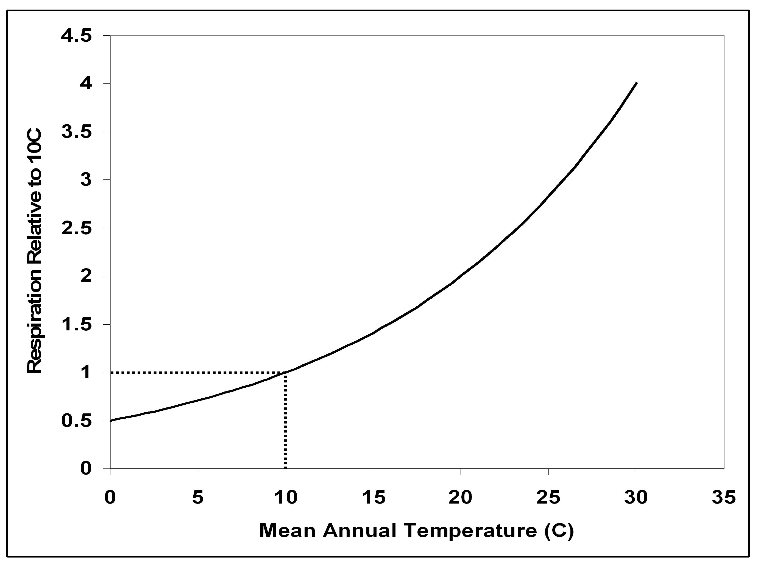

Figure 3-9. Response of live plant part respiration to mean annual temperature used in the LANDCARB model.

TempDecayIndex Function.

This function determines the effect of temperature on the decomposition rate of the detrital pools (Figure 3-10). The response to temperature has two components. The first part is an increase in respiration rate with temperature following a Q10 type curve. For each dead pool and each month the value of the following equation will be solved

MonPoolTempIncrease=(PoolQ10((MonTemp24-10)/10))

where the respiration rate of the layer at 10 C is assumed to be 1.0, and PoolQ10 is the rate respiration increases with a 10 C increase in temperature (see the DcayParm.prm file) and MonTemp24 is the temperature of a given month.

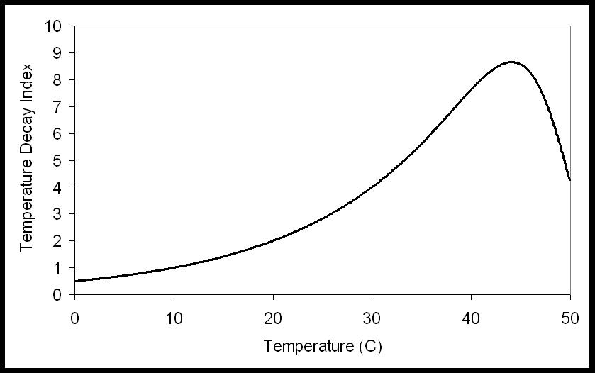

Figure 3-10. Relationship between temperature and relative effect on decomposition used in the LANDCARB model.

The second part of the temperature response simulates the effect of a lethal temperature limit that arrests decomposer activity. This equation is given by:

MonPoolTempLimit=Exp[-(MonTemp24/(PoolTempOpt+PoolTempLag))PoolTempShape]

where PoolTempOpt is the optimum temperature for decomposition of a dead pool and PoolTempLag and TempShape are parameters that determine the shape of the response curve as determined from the DecayPool.prm file.

The combined effects of these effects for each dead pool for each month is given by MonPoolTempDecayIndex:

MonPoolTempDecayIndex=MonPoolTempIncrease*MonPoolTempLimit

AbioticDecayIndex Function.

This function calculates the combined effects of temperature and moisture on the decomposition rate of each detrital pool and the stable soil pool for each month.

For each dead pool or the stable soil pool the monthly abiotic decomposition index (MonPoolAbioticIndex) is

MonPoolAbioticIndex=MonPoolMoistDecayIndex*MonPoolTempDecayIndex

The mean annual AbioticIndex (PoolAnnualAbioticIndex) for each dead pool or the stable soil pool is then used to control the decomposition rates in Decompose.

TempProdIndex Function.

This function determines the effect of temperature on net photosynthesis of each layer (Figure 3-11). The curve used to simulate this relationship is taken from Running and Coughlan (1988) and defines the mean daytime temperature (MonTempDay; see TempConvert function above) response according to a minimum and maximum temperature compensation point (LayerTempMin and LayerTempMax) for each layer as defined in the Growth.prm file. If the mean daytime temperature exceeds either the minimum or maximum temperature compensation points of a layer, then the temperature production index (LayerTempProd) for a layer is set to zero. If the daytime temperature is within those limits then:

MonLayerTempProdIndex=(LayerTempMax-MonTempDay)*(MonTempDay-LayerTempMin)/(LayerTempMax-LayerTempOpt)*(LayerTempOpt-LayerTempMin)

where MonLayerTempProdIndex is a relative index of the response of each layer to a monthly daytime temperature (MonTempDay).

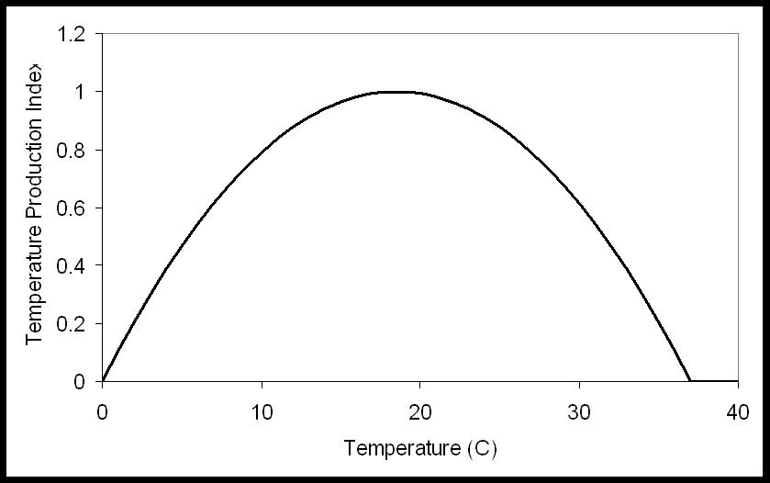
Figure 3-11. Relationship between temperature and relative photosynthetic rate used in the LANDCARB model.

The optimum temperature (LayerTempOpt) for a layer is defined as:

LayerTempOpt= (LayerTempMax-LayerTempMin)/2

MoistProdIndex Function.

This function determines the effect of soil moisture on the production of live biomass (Figure 3-12). We assume there is no effect on production of live biomass when either waterlogging occurs. In a future version we hope to implement a reduction in production for soils in which the water potential is less than -0.1 MP. This would account for a more realistic assumption that poor drainage and waterlogging reduces production. The current equation giving the waterlogging response is:

MonWaterLoggingIndex=1

where MonWaterLoggingIndex is the reduction of waterlogging on production.

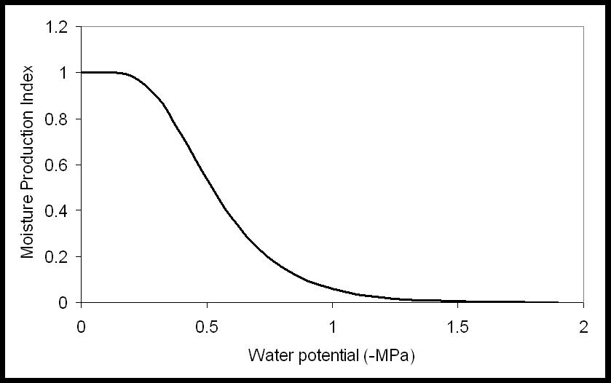

Figure 3-12. Relationship between soil water potential and relative photosynthetic rate used by the LANDCARB model.

When soil water potential (WaterPot) is below -0.3 MPa, the production rate decreases exponentially as a function of drought (Emmingham and Waring 1977). The equation describing this response is:

MonDroughtIndex=1-(1-exp[-5*MonWaterPot])9

where MonDroughtIndex is the reduction in production caused by drought. The overall effect of water potential on production (MonMoistProdIndex) is:

MonMoistProdIndex=MonWaterLoggingIndex*MonDroughtIndex

ProdIndex Function.

This function combines the monthly effects of moisture and temperature on the production rate of living biomass for each plant layer. In addition to indicating the response of production, it is also used to control the transpiration of the layers in the PET & Transpire functions. For each month the product of these two indices is computed:

MonLayerProdIndex=MonLayerTempProdIndex*MonMoistProdIndex

The mean annual production index (AnnualLayerProdIndex) is then computed and used by the GROWTH module.

